Assignment #4

Hector Lopez EEL6935

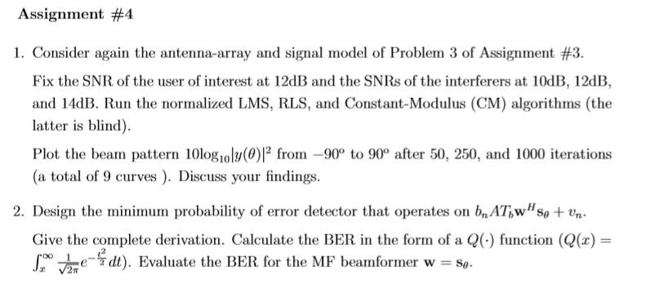

# Part 1

Normalized LMS and RLS seam to provide similar responses until we use a large sample size. At that point the LMS and RLS seems to diverge in response. The CM algorithm seems to respond similarly in all record sizes.

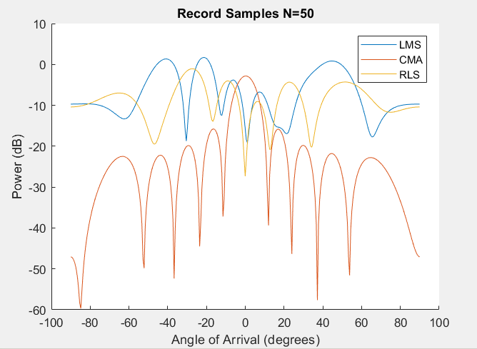

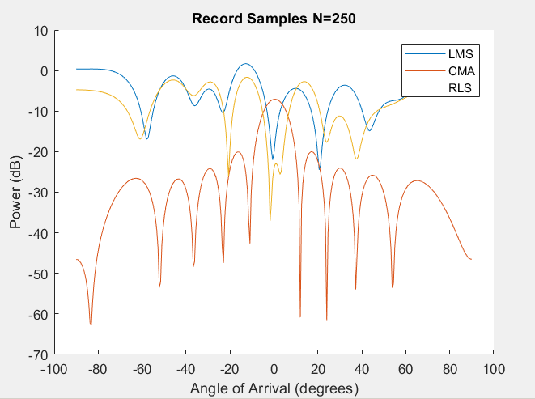

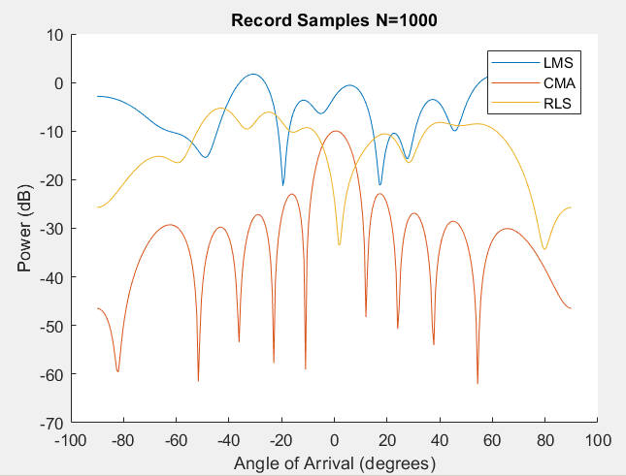

%%% Data Generation

clear all;

M=10; % Number of elements in antenna array

N=[50,250,1000]; % Data record sets sizes

K=3; % number of interfers signals

I=eye(M); % identity matrix

sigma=1; % variance

c=1; % constant

u=0.0000001; % small gain factor for LMS

beta=0.95;% forgetting factor, with 20 sample memory

eps0=1;% RLS initial value constnat for R^-1(1)

E0=10^(12/10);%12dB

%interfers signals

E1=10^(10/10);%10dB

E2=10^(12/10);%12dB

E3=10^(14/10);%14dB

theta=-pi/2:0.01:pi/2;%range of theta for user signal analysis

%th0=20; %angle of arrival for user signal

%th1=-80;

%th2=80;

%th3=60;

th_i=[-31,62,19,-68]/180*pi;

fc=2*10^6;%carrier frequency

lambda_c=fc/(3*10^8);%carrier wavelength

d=lambda_c/2;%nyquist distance

%create array response vectors for each incoming interfer

S0=zeros(M,1);S1=zeros(M,1);S2=zeros(M,1);S3=zeros(M,1);

for m=1:M

S0(m)=exp((-1i*2*pi*(m-1)*d)*sin(th_i(1)));

S1(m)=exp((-1i*pi*(m-1)*d)*sin(th_i(2)));

S2(m)=exp((-1i*pi*(m-1)*d)*sin(th_i(3)));

S3(m)=exp((-1i*pi*(m-1)*d)*sin(th_i(4)));

end

wcma = zeros(M,N(3));

wcma(:,1)=S1/M;

wlms=zeros(M,N(3));

wrls=zeros(M,N(3));

R=(1/eps0)*I;

%%% Simulation

for i=2:N(3)

% get three new random bits for each signal

b=complex(sign(randn(K,1)));

b0=complex(sign(randn(1)));

%BPSK Signal

n = sqrt(sigma)*complex(randn(M,1), randn(M,1))/sqrt(2);

r=b0*sqrt(E0)+b(1)*sqrt(E1)*S1+b(2)*sqrt(E2)*S2+b(3)*sqrt(E3)*S3+n;

R=(1/beta)*(R-((R*r*ctranspose(r)*R)/(beta+ctranspose(r)*R*r)));

wlms(:,i)=wlms(:,i-1)-(c/(norm(r)^2))*r*(ctranspose(r)*wlms(:,i-1)-conj(b0));

wcma(:,i)=wcma(:,i-1)-u*r*ctranspose(r)*wcma(:,i-1)*(abs(wcma(:,i-1)'*r)^2-E0);

wrls(:,i)=wrls(:,i-1)-R*r*(r'*wrls(:,i-1)-conj(b0));

end

%% Data Analysis

for k = 1:3

for th=1:length(theta)

x=zeros(M,1);

for m=1:M

x(m)=exp((-1i*pi*(m-1))*sin(theta(th)));

end

ylms(th)=wlms(:,N(k))'*x;

ycma(th)=wcma(:,N(k))'*x;

yrls(th)=wrls(:,N(k))'*x;

end

ylms_db = 10*log10((abs(ylms).^2));

ycma_db = 10*log10((abs(ycma).^2));

yrls_db = 10*log10((abs(yrls).^2));

theta_deg = 180*theta/pi;

figure

hold on

plot(theta_deg,ylms_db)

plot(theta_deg,ycma_db)

plot(theta_deg,yrls_db)

title(sprintf('Record Samples N=%d',N(k)));

legend('LMS','CMA','RLS');

xlabel('Angle of Arrival (degrees)');

ylabel('Power (dB)');

end

# Part 2

